1. **Installing Windows 11 on your PC:**

**System Requirements:** Before you begin, ensure your PC meets the minimum system requirements for Windows 11.Use the PC Health Check app to verify compatibility.

**Backup Your Data:** It’s crucial to back up your files to avoid any data loss during the installation process.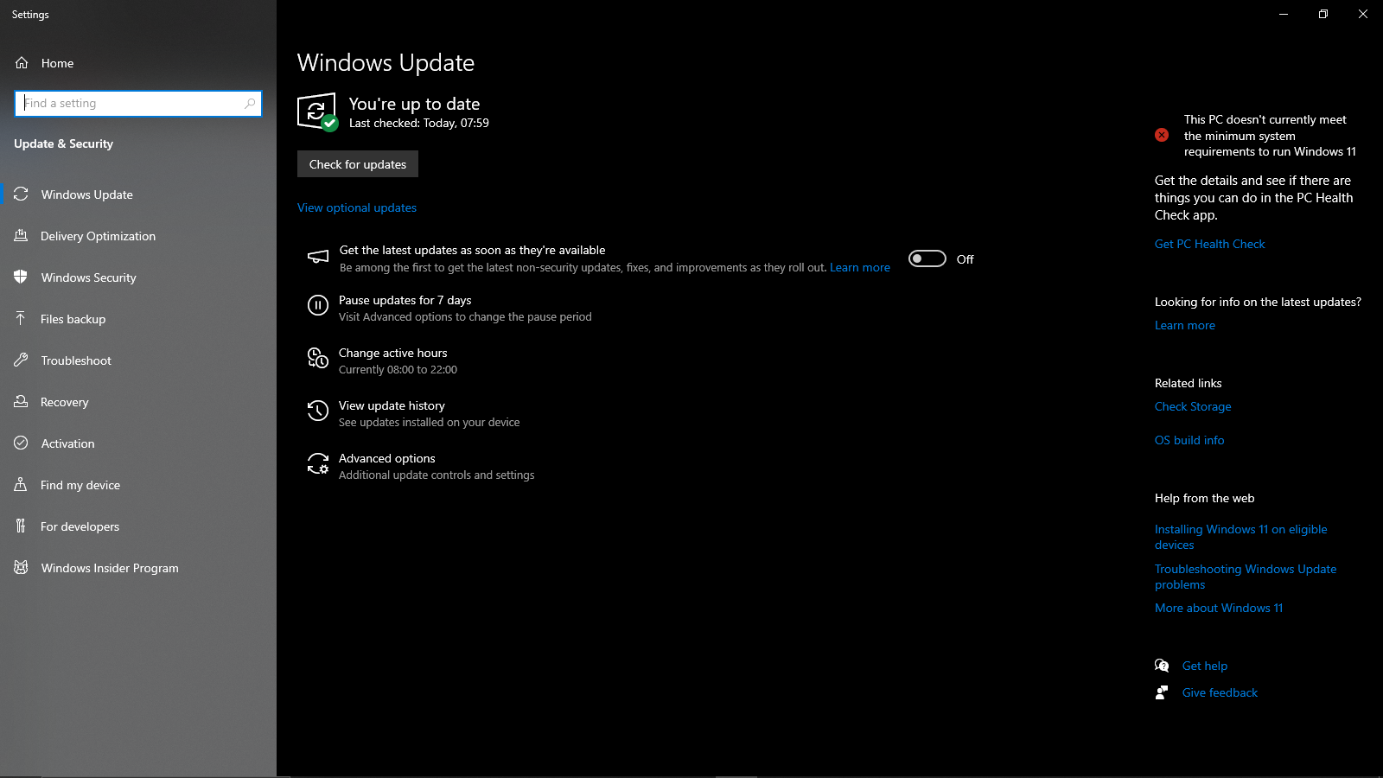

**Create Installation Media:** Download the Windows 11 Media Creation Tool from Microsoft’s website. Run the tool and follow the instructions to create a bootable USB flash drive or DVD.

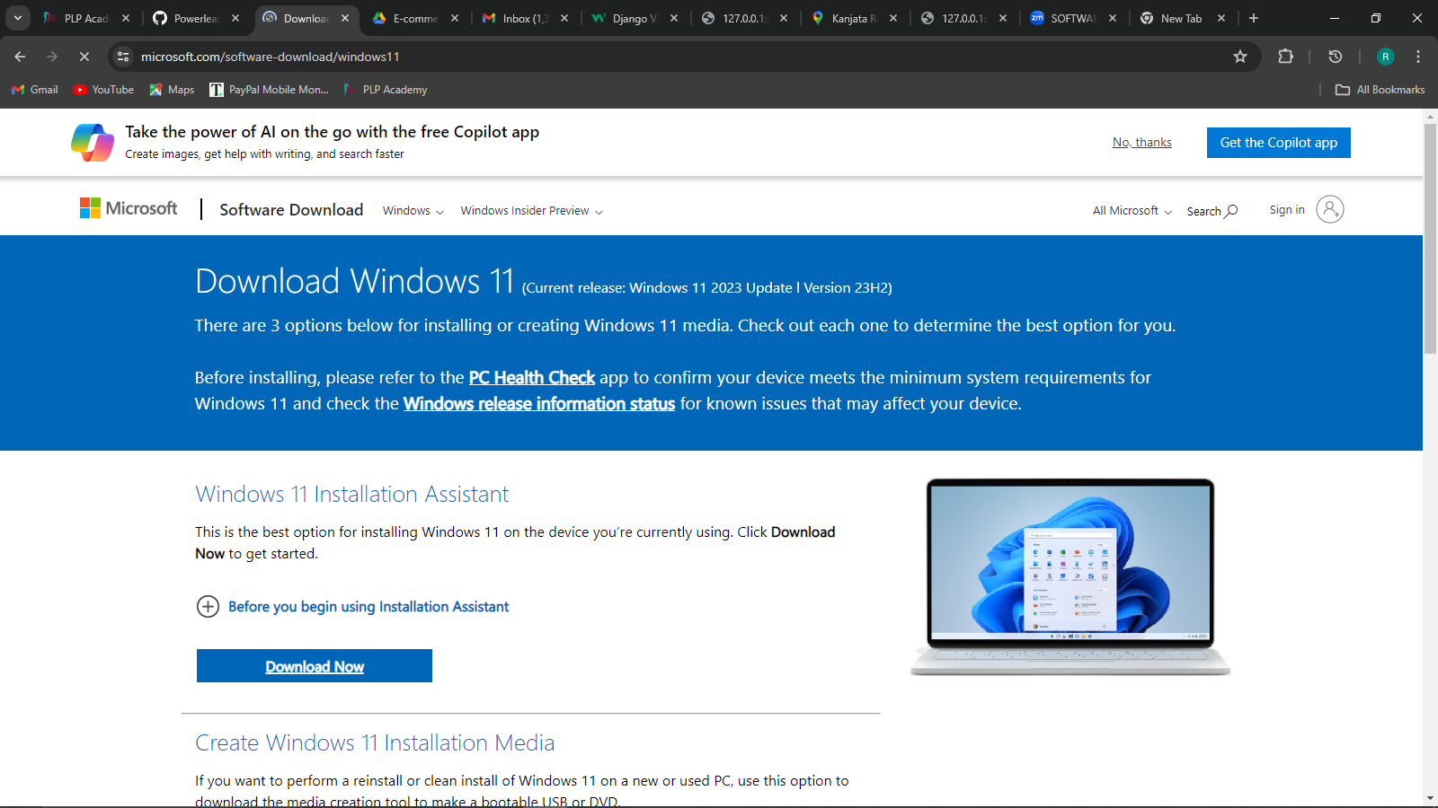

**Boot from USB/DVD:** Insert the installation media into your PC and reboot. Enter the BIOS setup (usually by pressing F2, F12, Del, or Esc during startup) and set the boot order to start from the USB/DVD.

**Install Windows 11:** Once booted from the media, follow the on-screen prompts. Select the language, time, currency, and keyboard preferences. Click ‘Install Now.’

**Activation:** Enter your Windows 11 product key when prompted. If upgrading, your PC might automatically activate online.

**Choose Installation Type:** For a fresh install, select ‘Custom: Install Windows only (advanced).’ For an upgrade, choose ‘Upgrade: Install Windows and keep files, settings, and applications.’

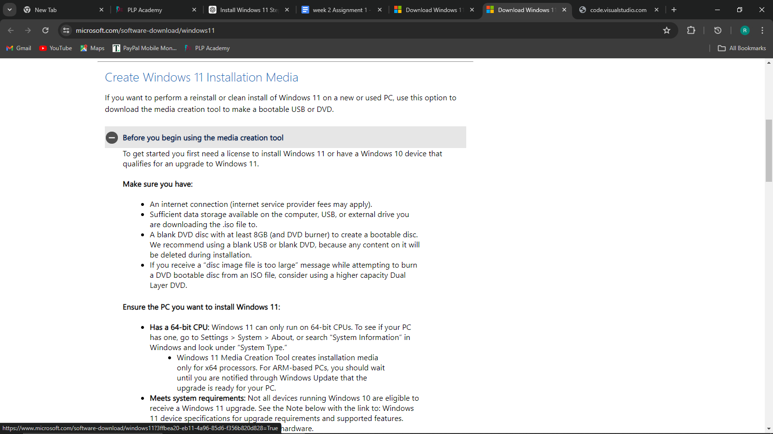

**Partition Selection:** If performing a clean install, select the drive or partition where you want to install Windows. You may need to format or delete partitions.

**Installation Process:** Windows will begin installing. Your PC will restart several times during this process. Remove the USB/DVD after the first reboot to prevent restarting the installation.

**Finalize Setup:** After installation, set up your preferences for privacy settings, network, and account creation. You can use a Microsoft account or create a local account.

**Update Drivers:** Once Windows 11 is installed, check for updates and install any necessary drivers for your hardware.

**Restore Data:** If you backed up your data, now is the time to restore it to your new Windows 11 installation.

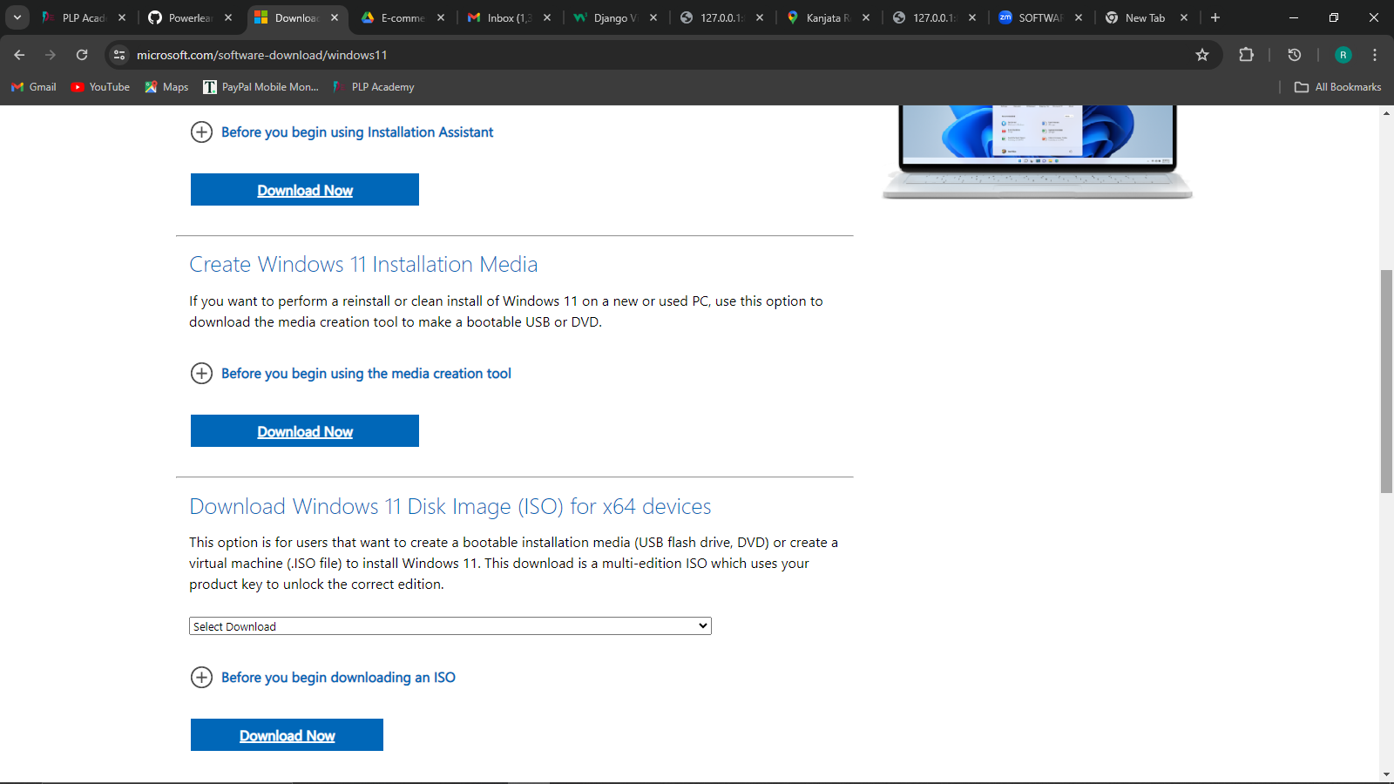

1. **Installing Visual studio on my PC**

* **Download the Installer**:

Visit the VS Code download page.

Click on the Windows download link to download the installer.

* **Run the Installer:**

Locate the downloaded .exe file and double-click it to run the installer.

Follow the Installation Wizard:

Accept the agreement terms.

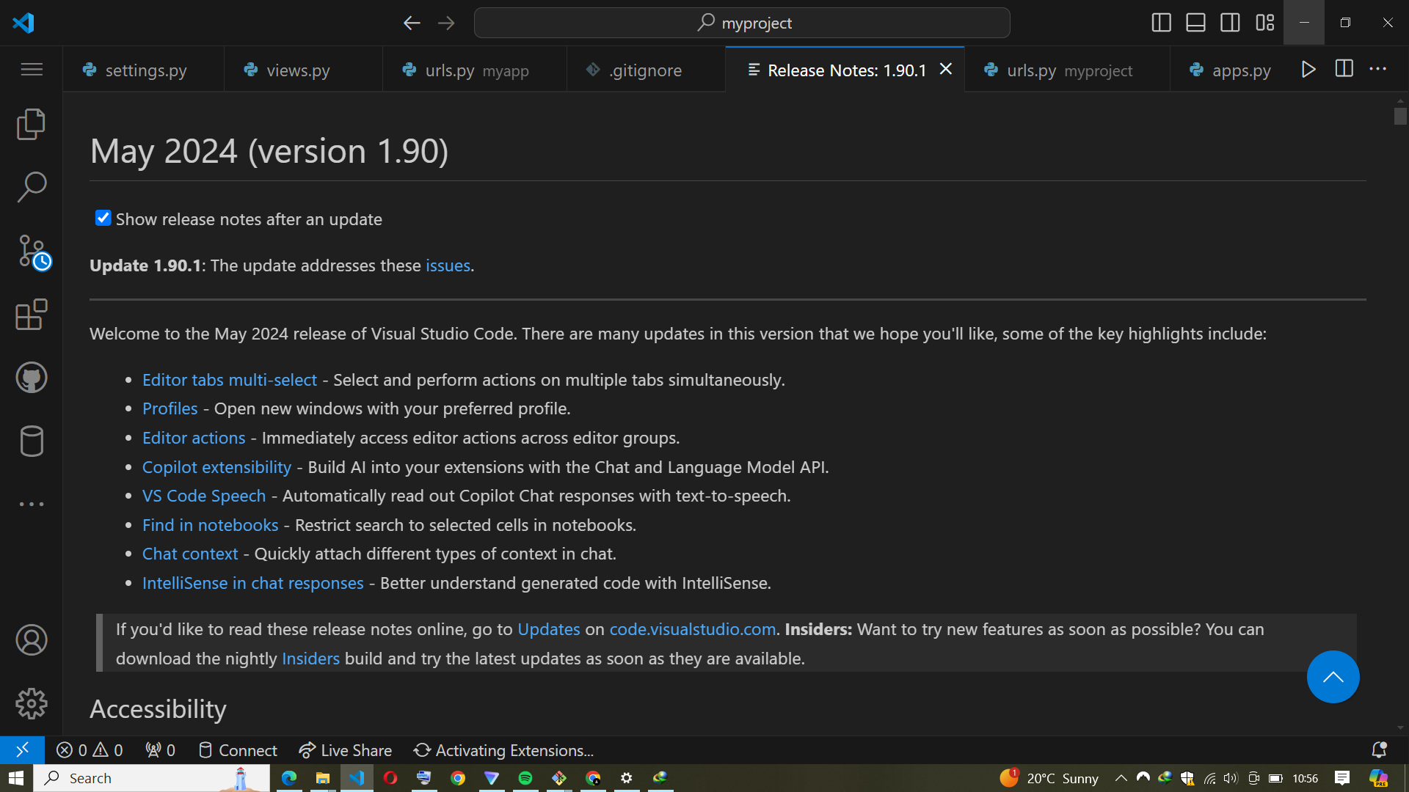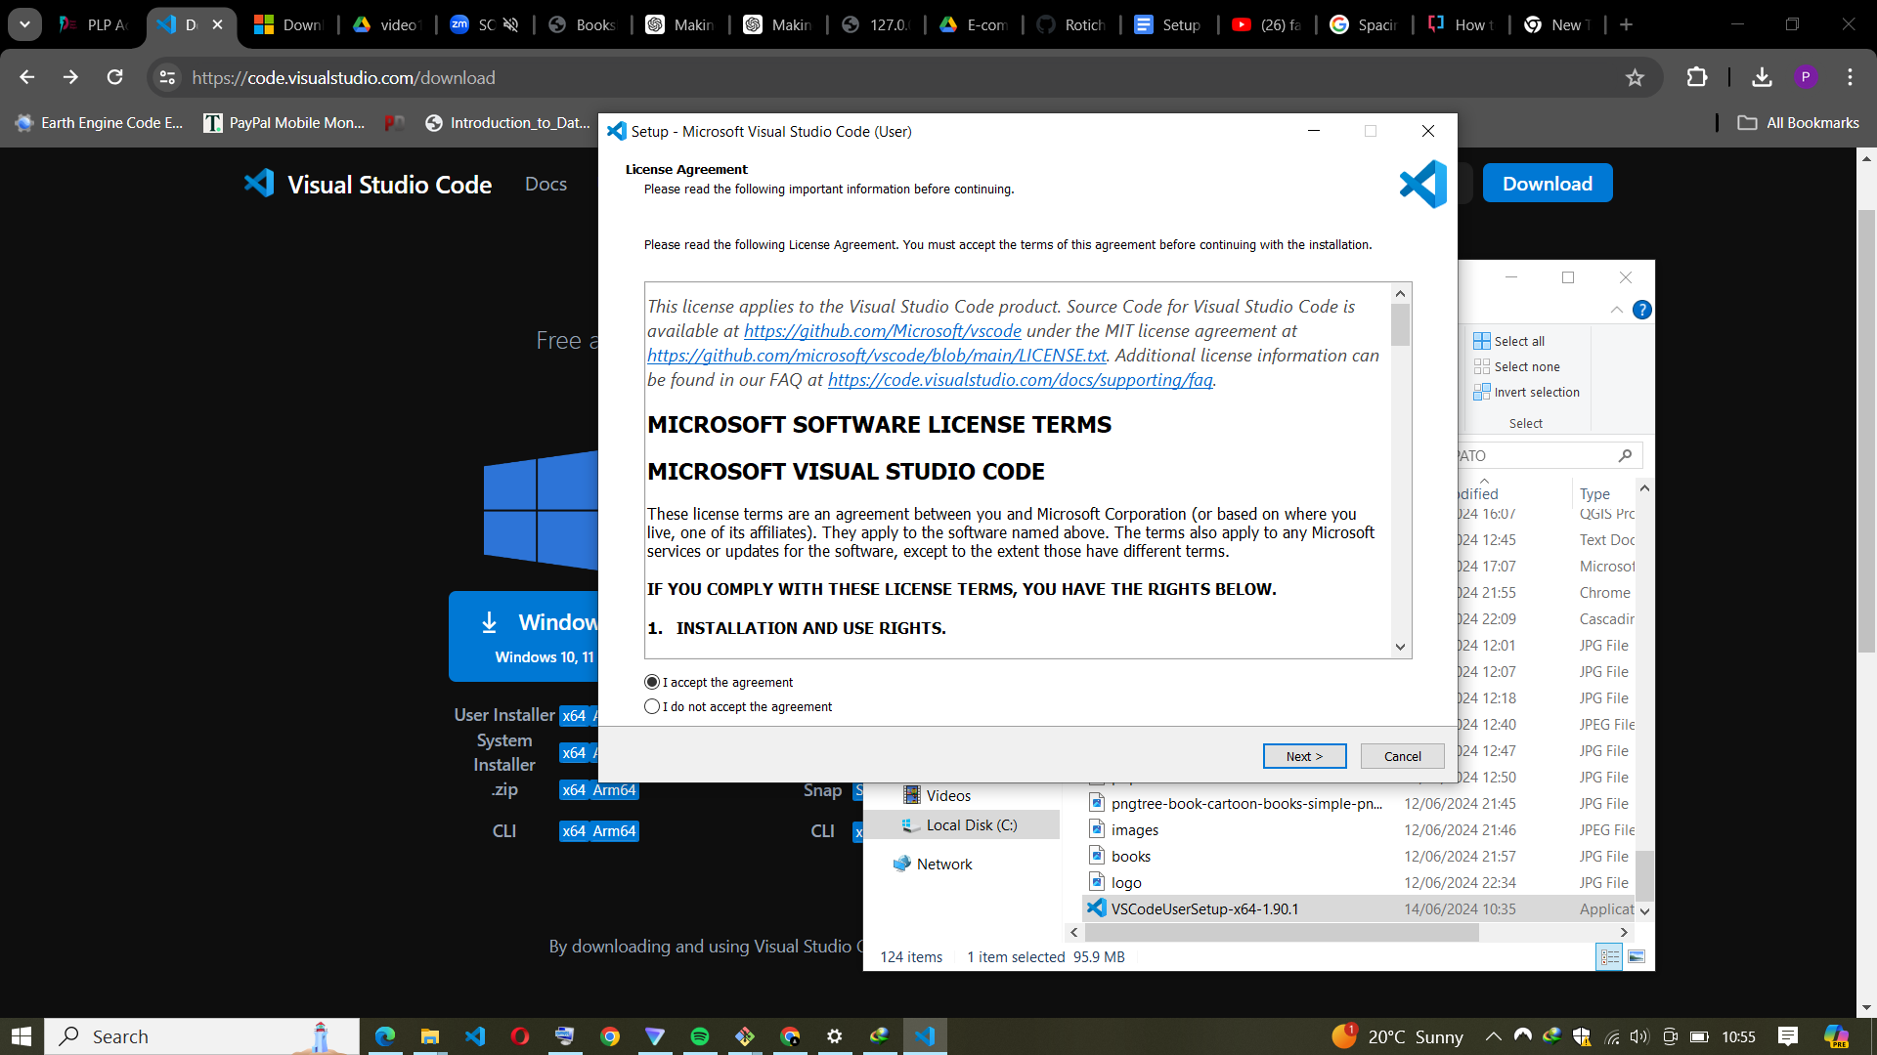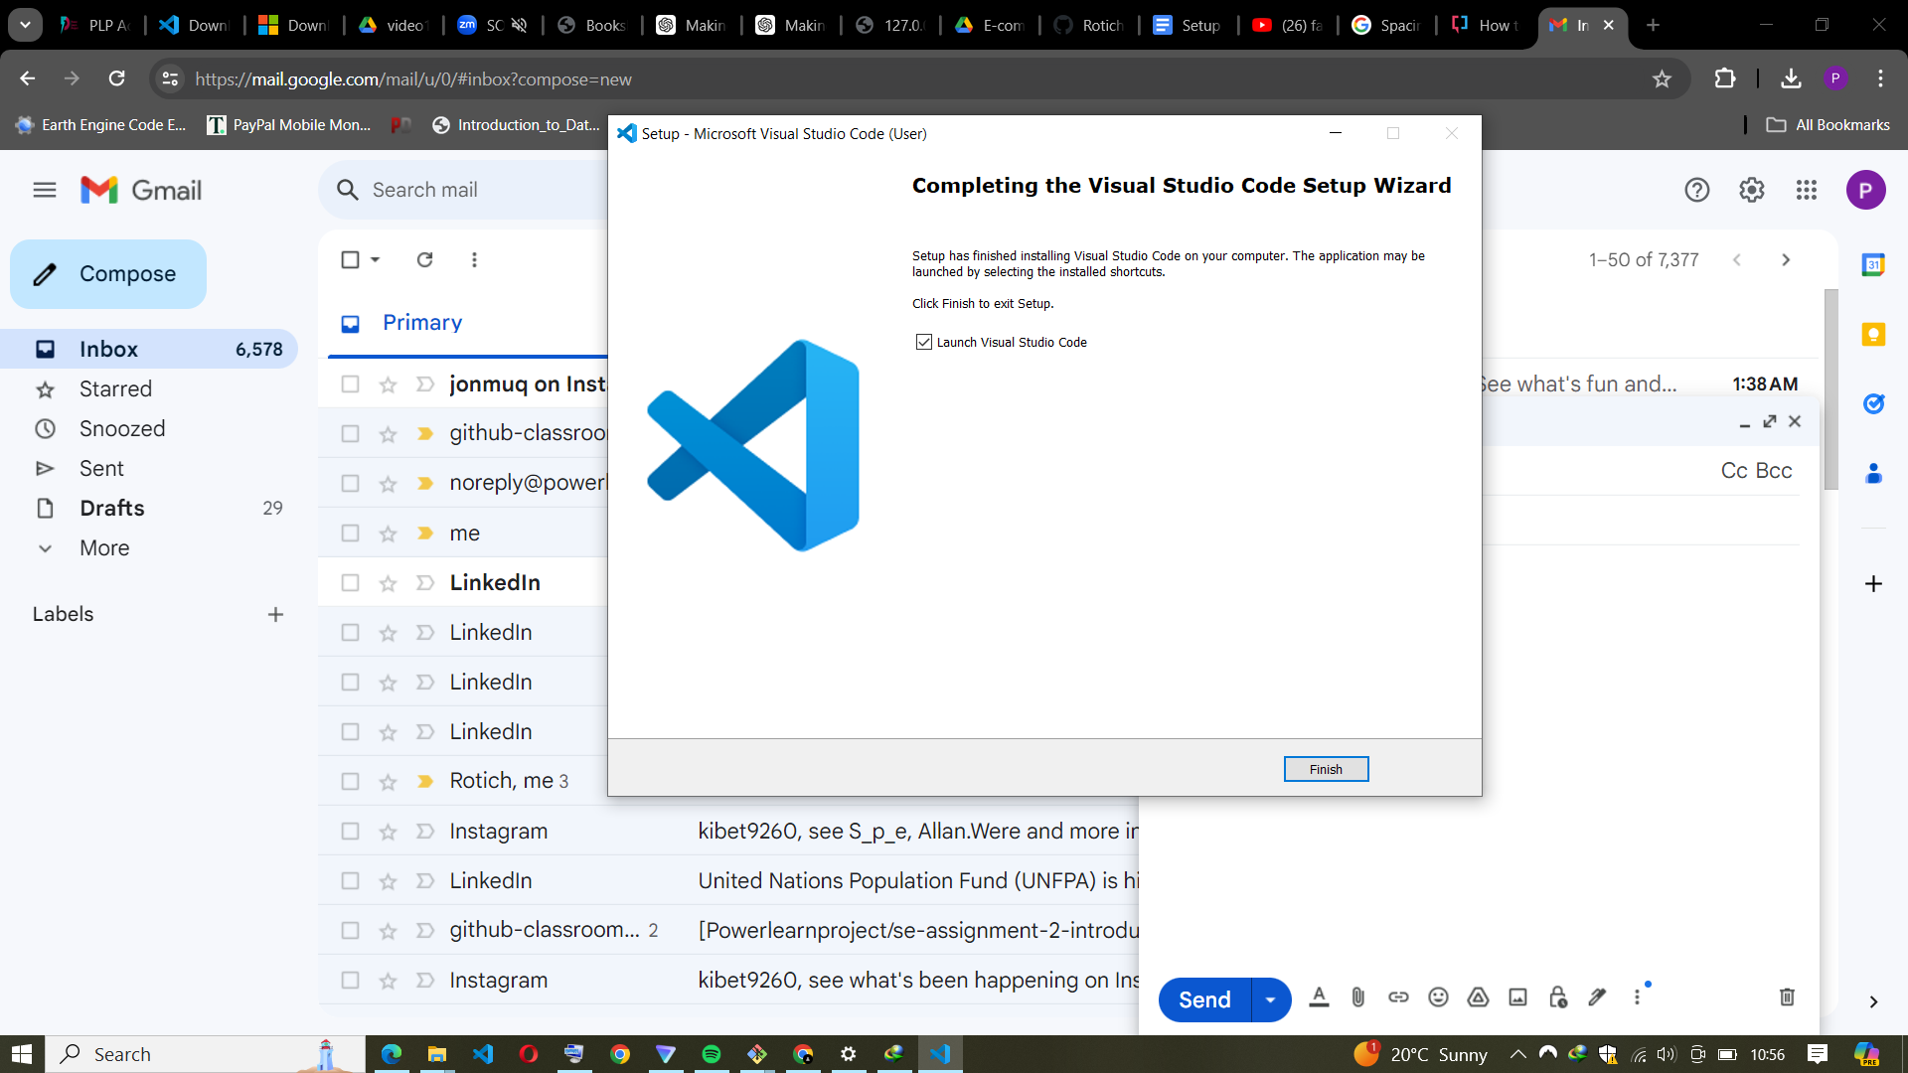

* **Choose the destination folder for the installation.**

Select additional tasks such as creating a desktop icon or adding VS Code to the PATH

Click "Install" and wait for the installation to complete.

Click "Finish" once the installation is done. VS Code should launch automatically if you

selected the option to do so.lling Visual studio code:

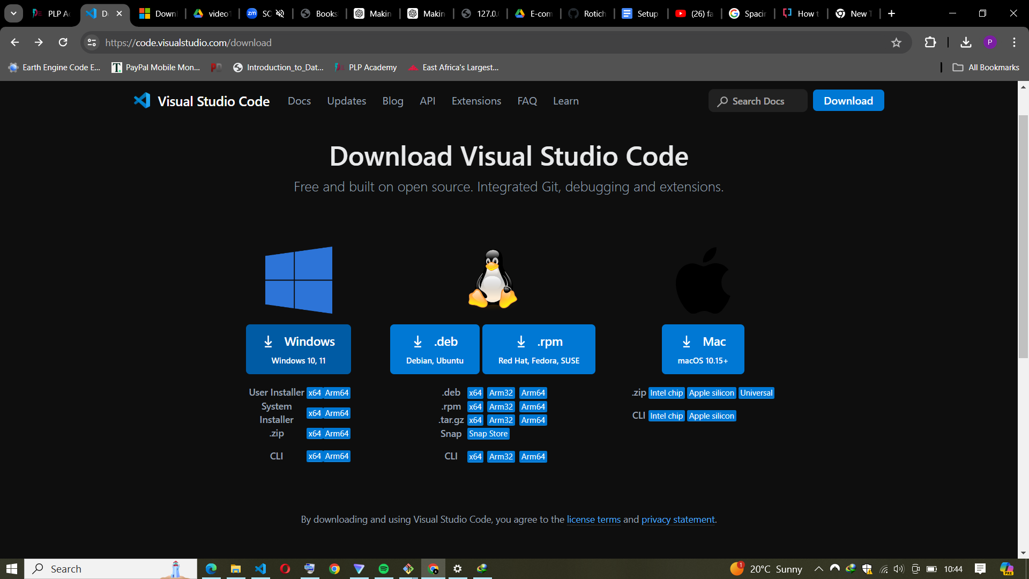

1. **Installing Git and Creating a Github account :**

* Install Git on Your Local Machine

To install Git, start by downloading the installer from the official Git website (git-scm.com). Choose the version compatible with your operating system (Windows, macOS, or Linux). Once downloaded, run the installer and follow the on-screen instructions. During installation, you can choose default settings or customize them based on your preferences. For Windows, ensure you select "Use Git from the command line and also from 3rd-party software" for easier access.

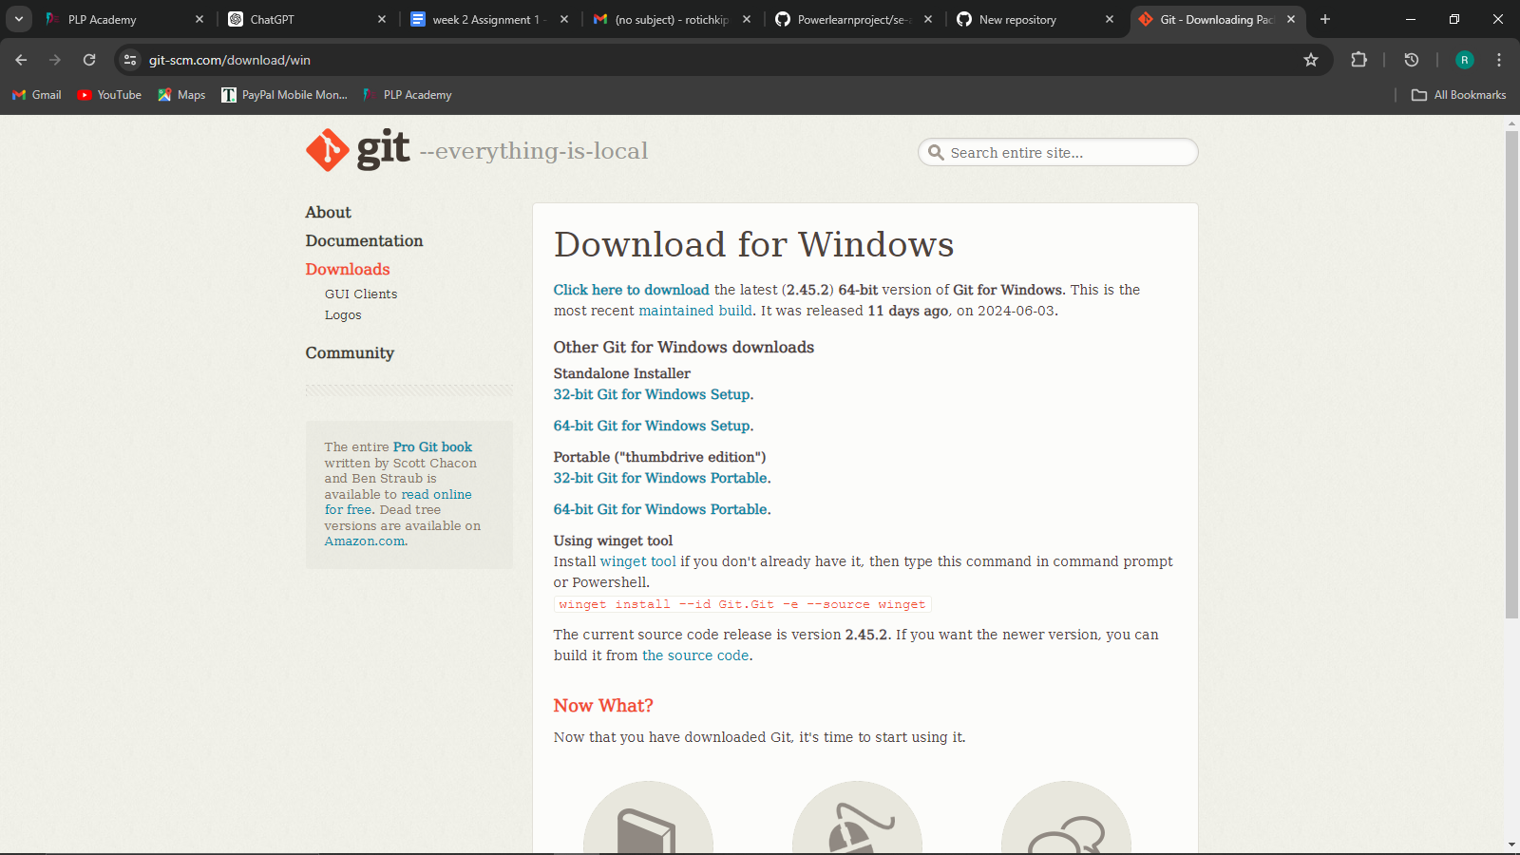

* Configure Git

After installation, open your terminal (Command Prompt, Git Bash, or Terminal). Configure Git with your user name and email, which will be associated with your commits. Execute the following commands:

***git config --global user.name "Your Name"***

***git config --global user.email "your.email@example.com"***

You can verify your configuration with:

***git config --global --list***

This step ensures that all your commits carry the correct identity.

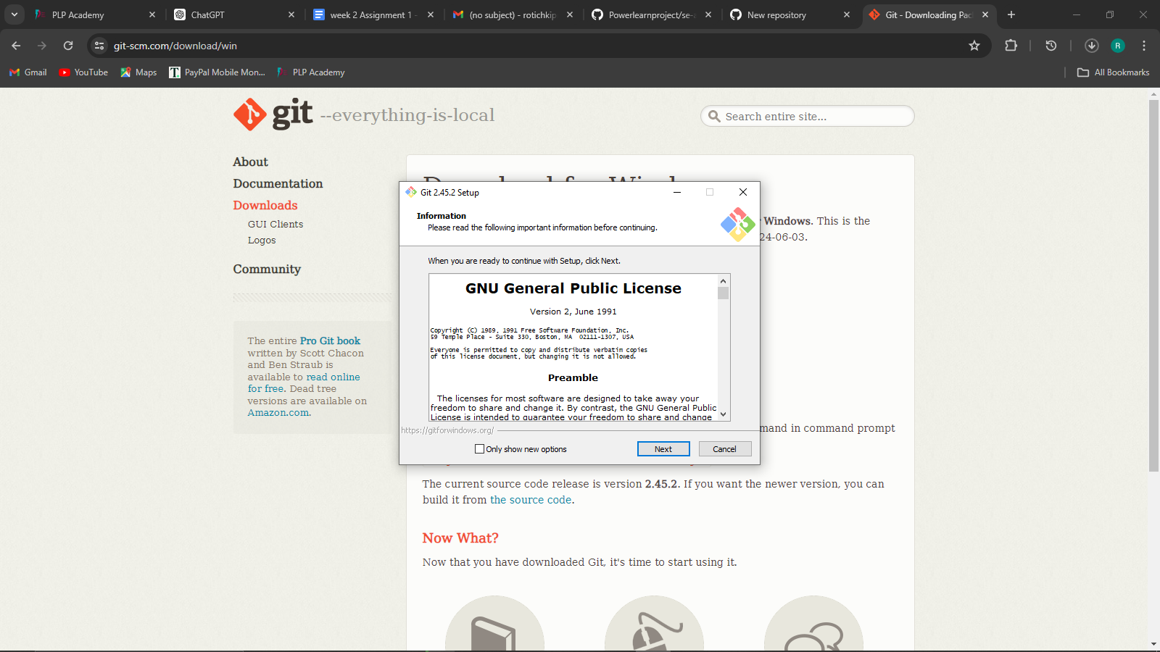

* Create a GitHub Account

Go to GitHub.com and sign up for an account. Choose a unique username, provide your email address, and set a strong password. Follow the prompts to complete the account creation process. After signing up, check your email for a verification link from GitHub and click it to verify your email address.



* Access the New Repository Page

Once you are logged in, click on the "+" icon located at the top right corner of the page, next to your profile picture. From the dropdown menu, select "New repository."

Fill in Repository Details

You will be directed to a page where you need to fill in the details for your new repository:

Enter a unique name for your repository.

Add a brief description of your project.

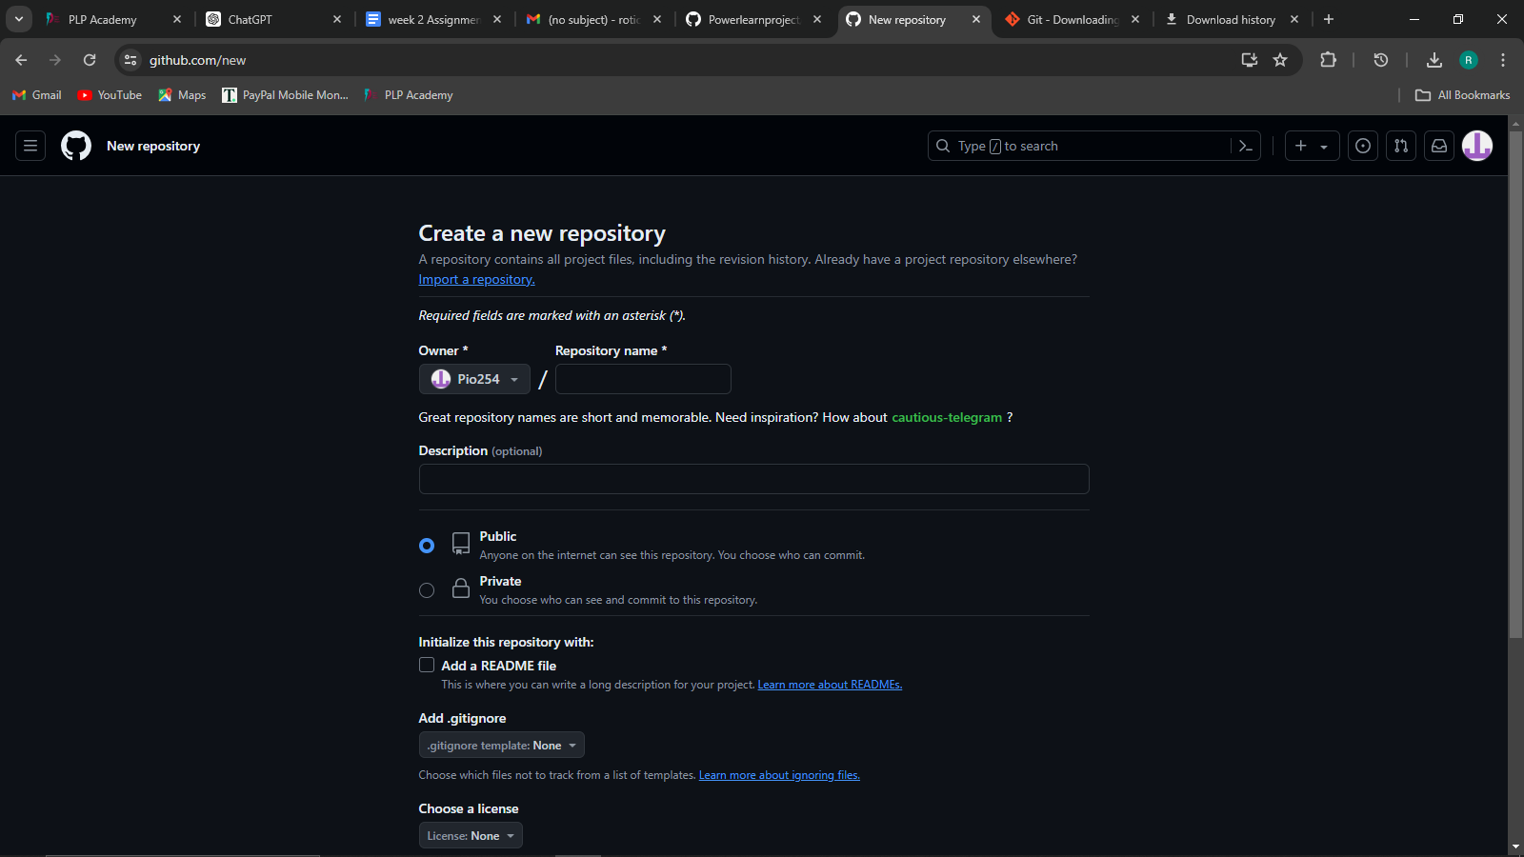

Choose whether you want your repository to be public (visible to everyone) or private (only visible to you and selected collaborators).

* Initialize Repository with a README

To make it easier to start, check the box that says "Initialize this repository with a README." This will create a default README file that you can edit later.

1. **Installing Python IDE:**

* Download Python Installer:

Go to the official Python website: python.org.

Navigate to the "Downloads" section and click on the download link for the latest version of Python suitable for Windows.

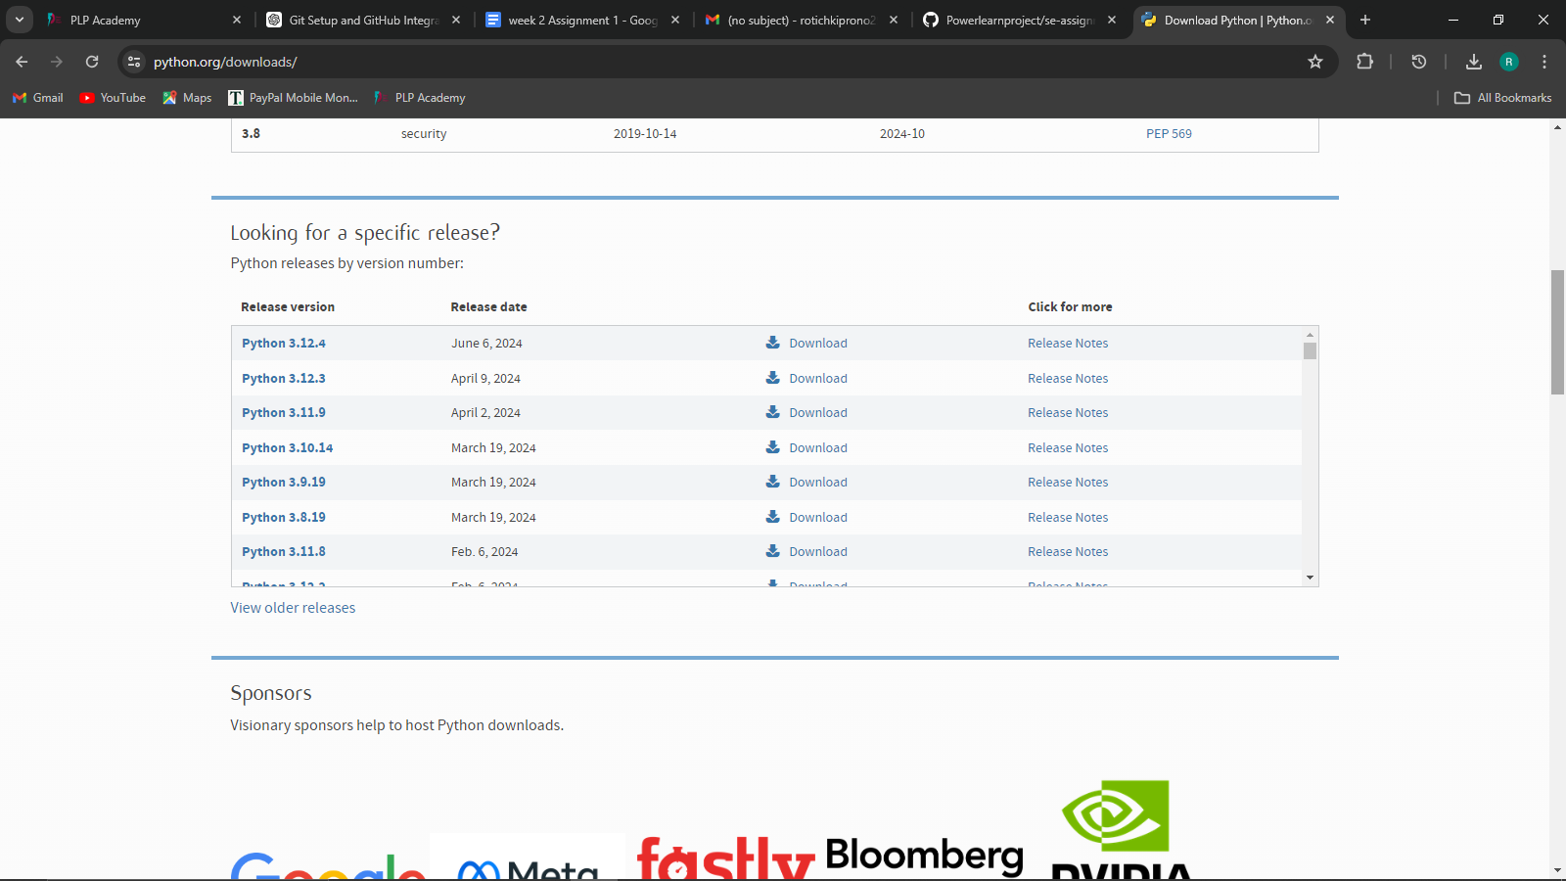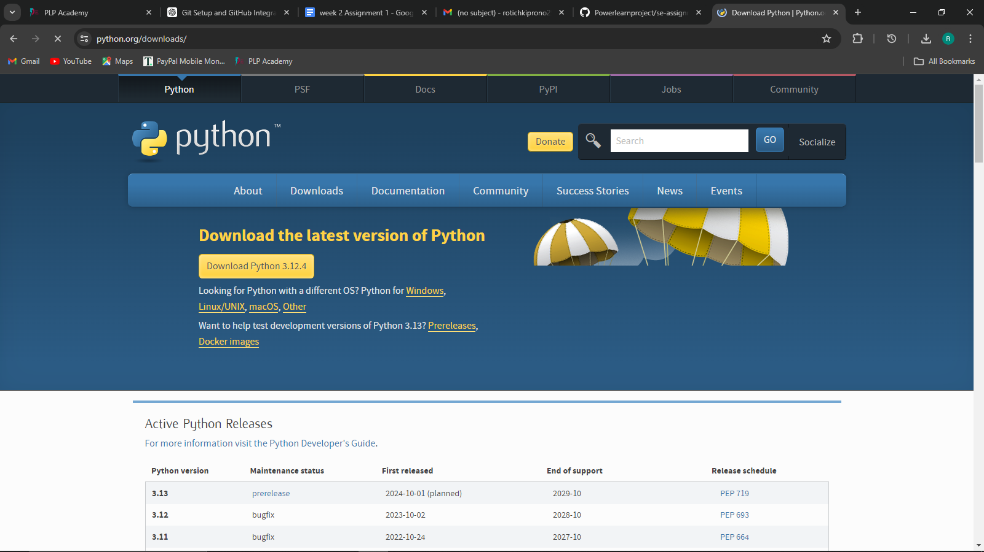

* Run the Installer:

Locate the downloaded installer file (python-<version>.exe) and double-click it to run.

In the installer window, ensure you check the box that says "Add Python to PATH." This will allow you to use Python from the command line.

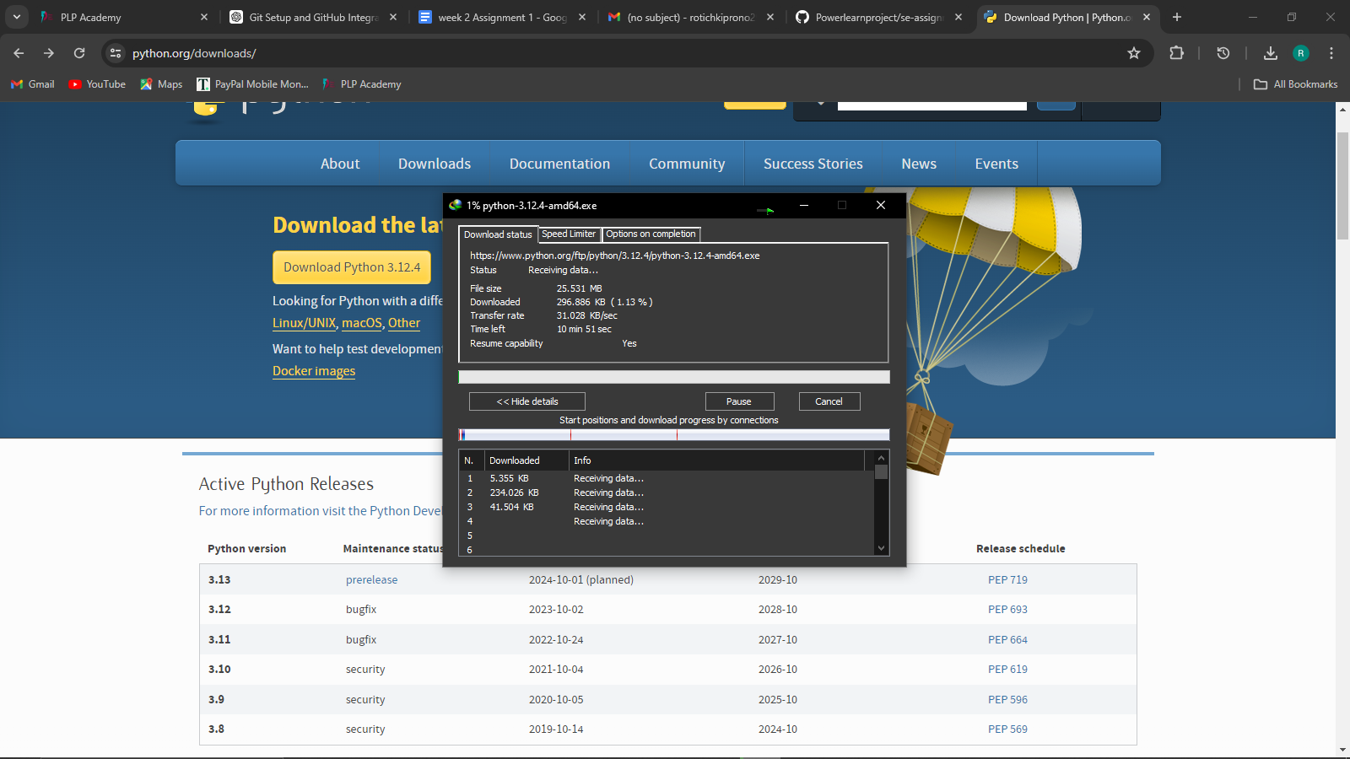

* Install Python:

Click on "Install Now" to install with default settings, or choose "Customize installation" if you need specific settings.

Follow the prompts and wait for the installation to complete.

* Verify Installation:

Open Command Prompt and type python --version to check the installed version of Python.

Additionally, type pip --version to check if pip (Python package installer) is installed.

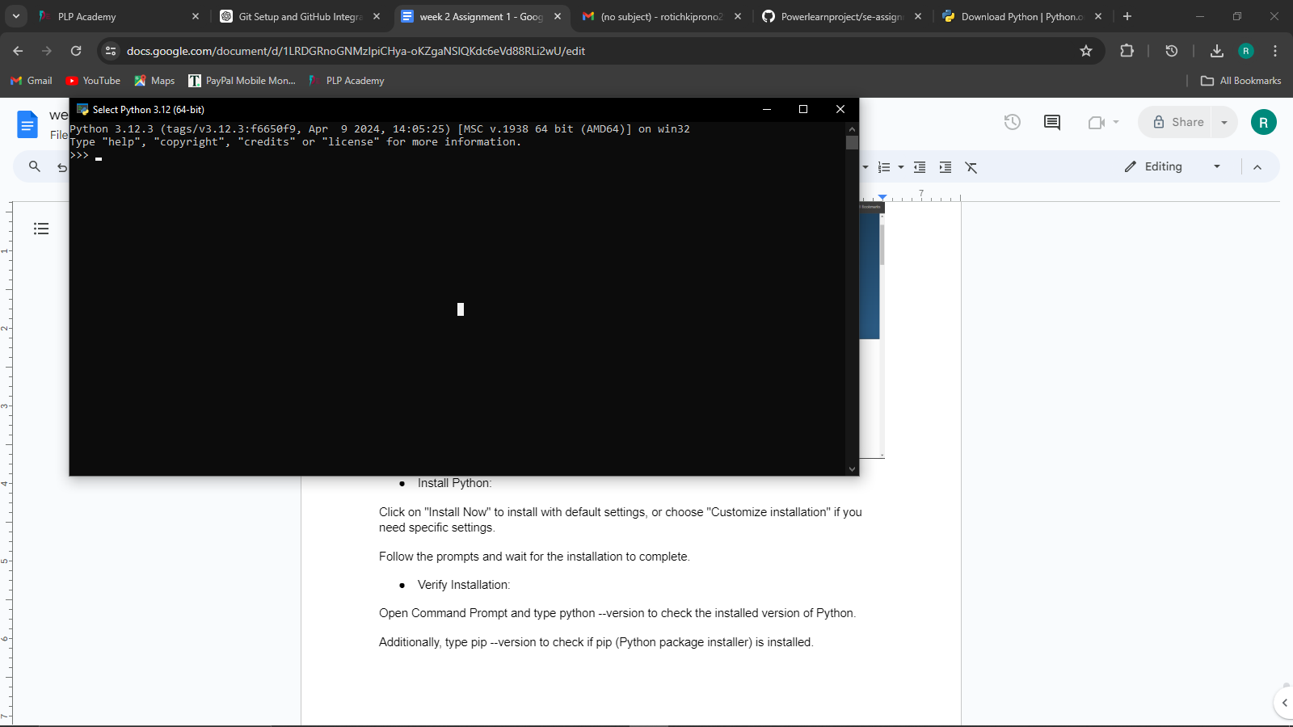

1. **Installing Package Managers:**

* Open Command Prompt and type:

***python --version***

If Python is not installed, follow the steps to install Python first.

Ensure pip is Installed:

Pip is usually included with Python installation from version 3.4 onwards. Verify pip installation by typing:

***pip --version***

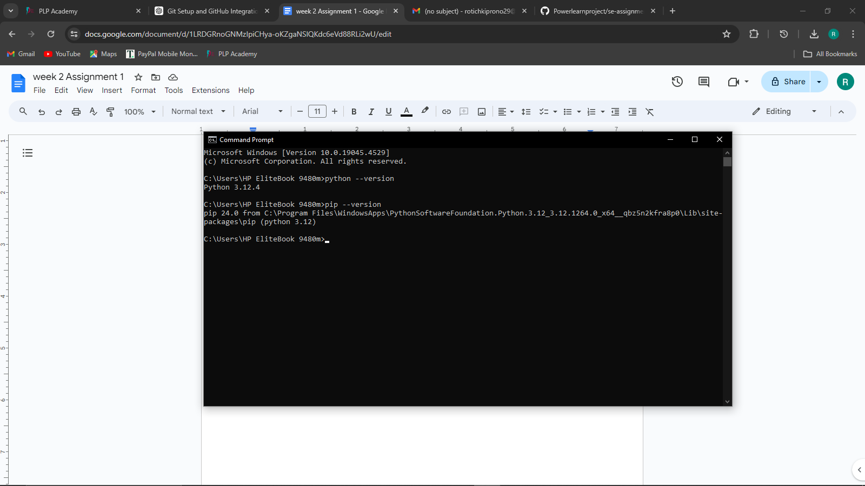

If pip is not installed, download get-pip.py by right-clicking this link and saving the file.

* Install pip:

Open Command Prompt and navigate to the directory where get-pip.py is saved:

***cd path\to\directory***

Run the following command to install pip:

***python get-pip.py***

1. **Configure a Database (MySQL): Download and install MySQL database.**

* Download MySQL

Visit the Official MySQL Website. Go to mysql.com and navigate to the "Downloads" section.

Choose the MySQL Community Edition, which is free to use.

* Install MySQL on Windows

Download the MySQL Installer:

Select "MySQL Installer for Windows" and download the installer (choose the appropriate version, typically the web installer).

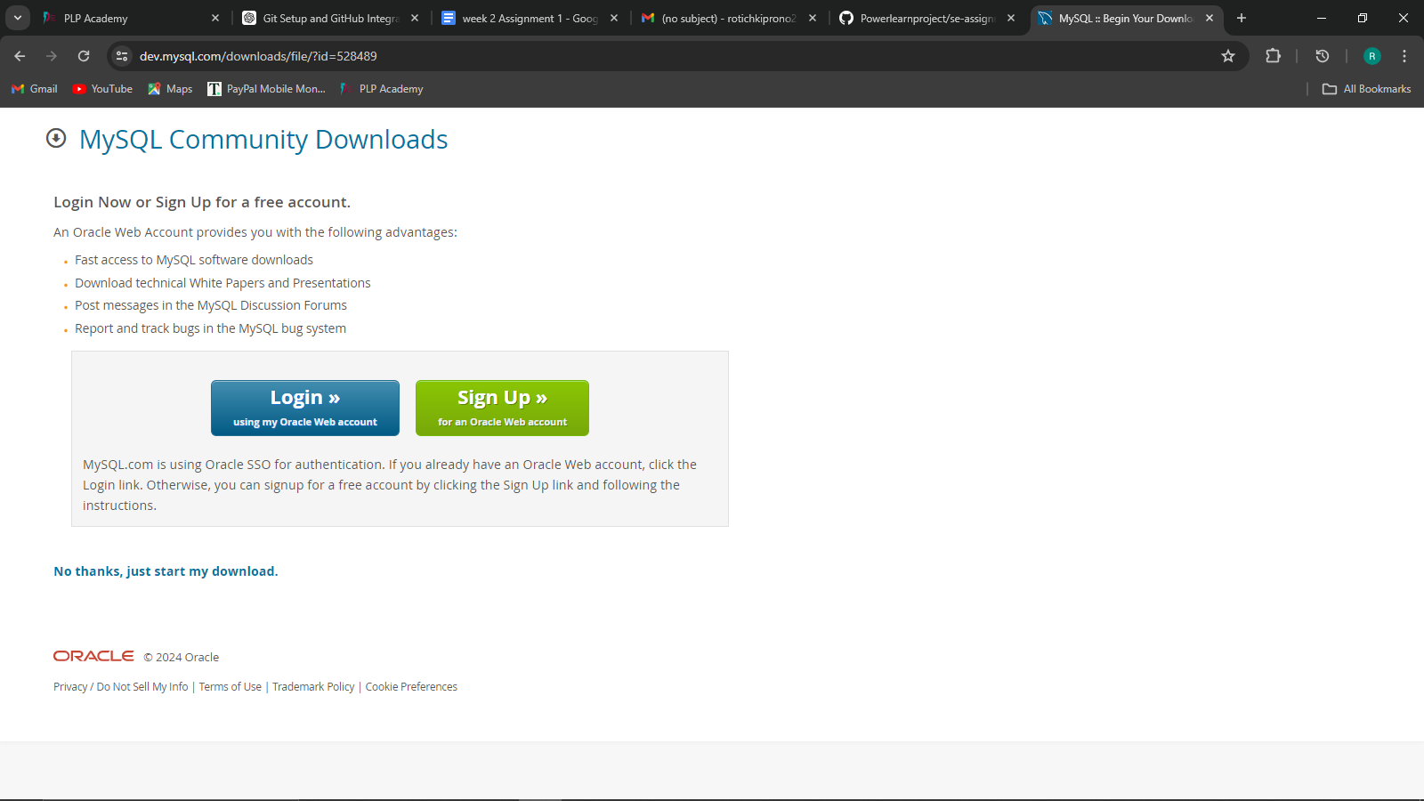

* Run the Installer:

Locate the downloaded .msi file and double-click to run it. Choose the setup type: "Developer Default" is a good choice for most users.

* Configure MySQL Server:

Follow the installation wizard, and when prompted, select "Standalone MySQL Server / Classic MySQL Replication."

Configure the server settings, including setting a root password and creating a user account.

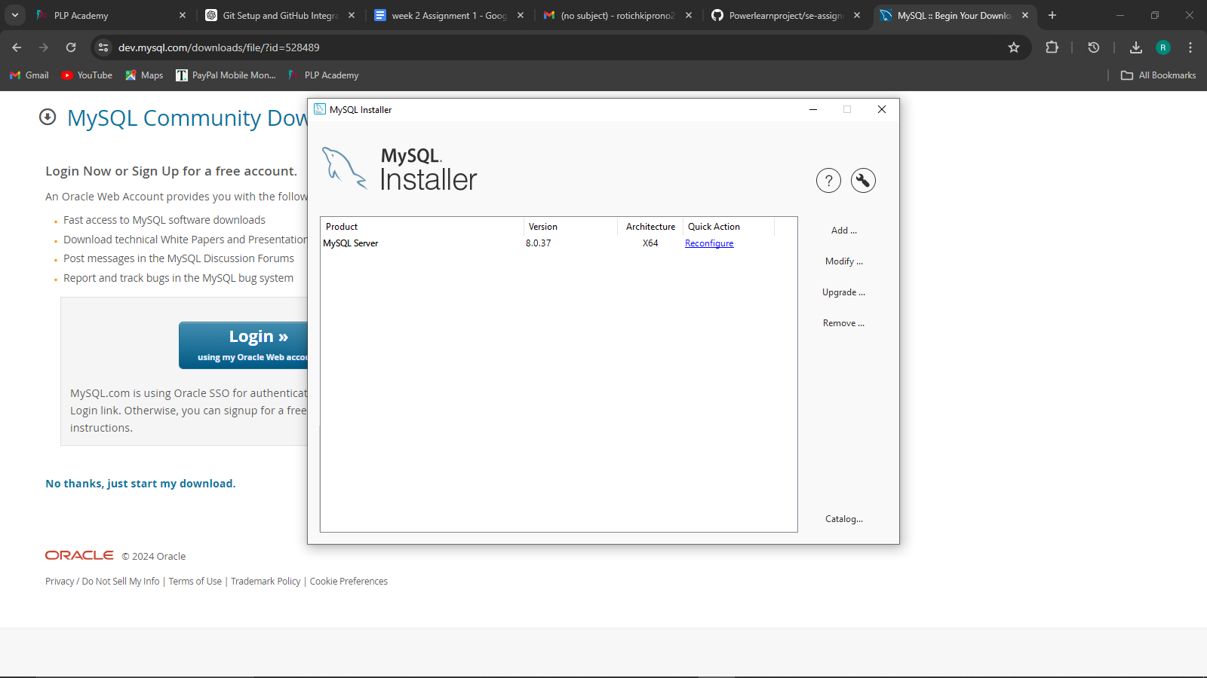

* Complete Installation:

Continue following the prompts, allowing the installer to install all necessary components.

When installation completes, ensure "Start MySQL Workbench after Setup" is checked, then click "Finish."

* Verify MySQL Installation:

Open your command line interface (Command Prompt, Terminal, or Linux shell) and type:  
  
***mysql --version***

You should see the version of MySQL that you installed.

* Connect to MySQL**:**

To connect to the MySQL server, type:  
  
***mysql -u root -p***

Enter the root password you set during installation.

* Create a Database**:**

Once connected, create a new database using the following SQL command:  
  
***CREATE DATABASE mydatabase;***

Replace ***mydatabase*** with your desired database name.

**7. Explore Extensions and Plugins:**

